**Assignment 24.6**

**Loading Data:**

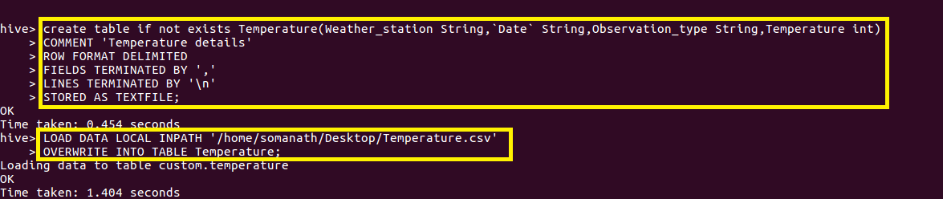

1. **Write a hive query to find the minimum temperature observed in a given weather station in a particular year.**

Since we want minimum temperature in a particular year, weather station.

I grouped by weather station and year part of date by using substr() function and used min() function to find minimum temperature.

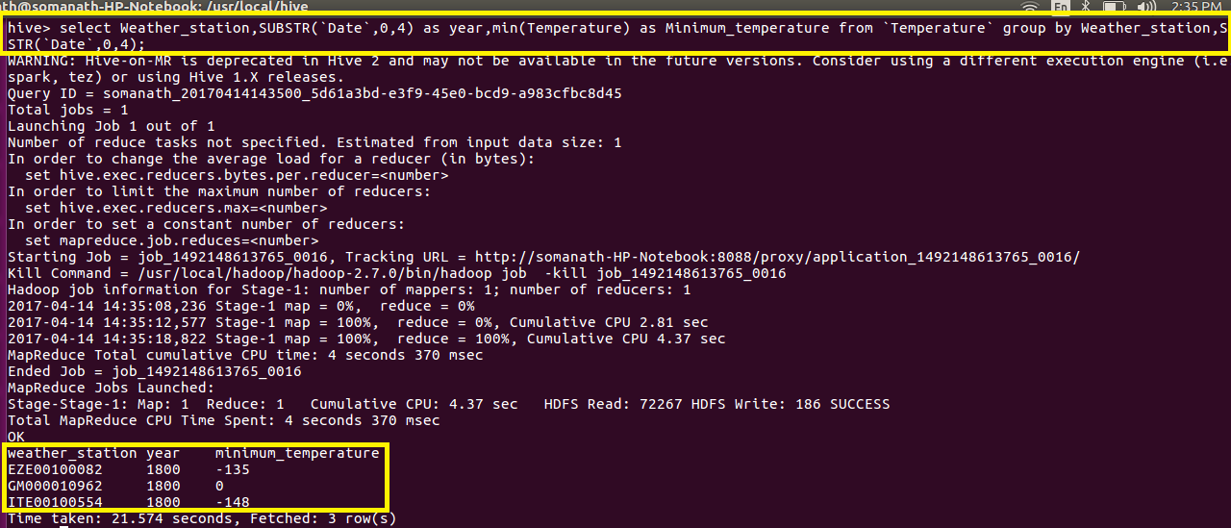

1. **Write a hive query to find the maximum temperature observed in a given weather station in a particular year.**

Since we want maximum temperature in a particular year, weather station.

I grouped by weather station and year part of date by using substr() function and used max() function to find minimum temperature.

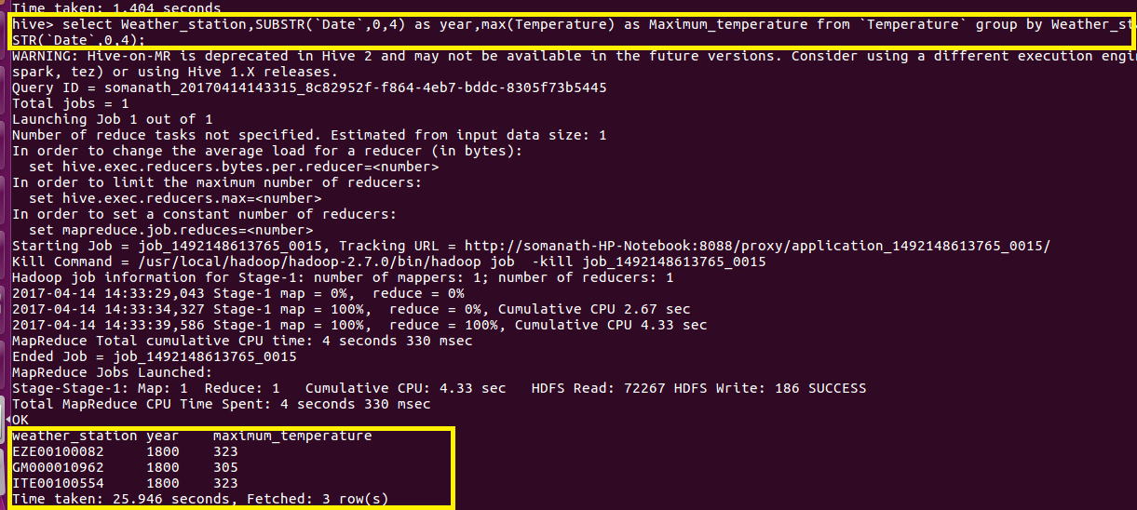

1. **Write a hive query to find the number of readings given by each weather station according to the dataset.**

Since we want number of readings for each weather station group by weather station and made a count of reading.

